|  |
| --- |
| LANGUAGE  **THE GINGERBREAD MAN** |

**I WANT TO EAT YOU !**

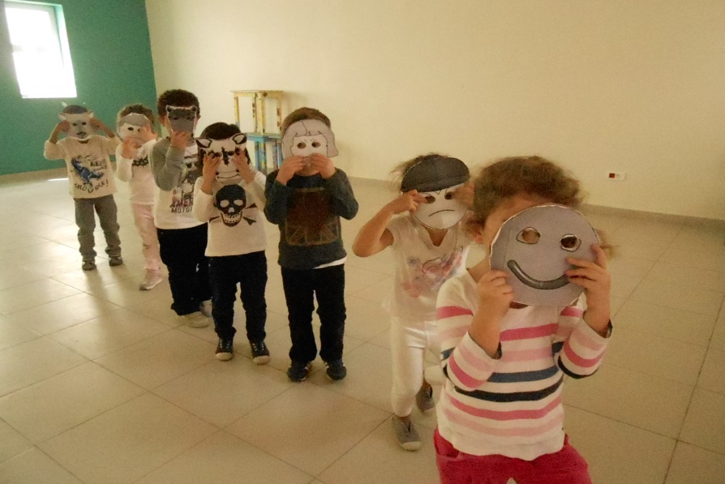

**RUN RUN. YOU CAN’T CATCH ME. I’M THE GINGERBREAD MAN !**

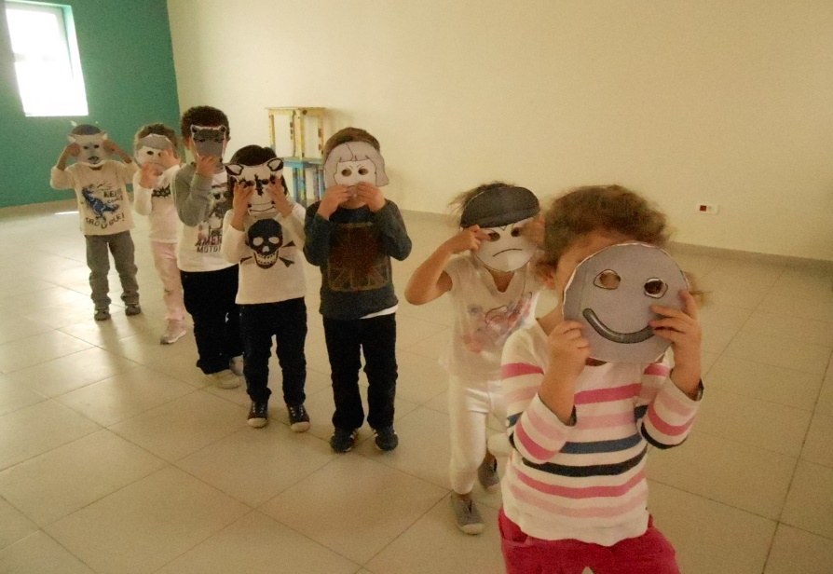

**YUMMY, YUMMY ! YOU ARE DELICIOUS !**

 **And, THAT is the end!**