LANGUAGE
GOLDILOCKS AND THE THREE BEARS

ONCE UPON A TIME …
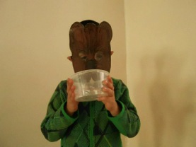
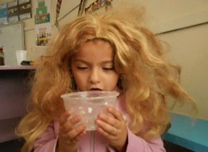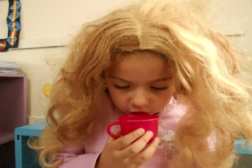
Goldilocks says : «This soup is hot!» Goldilocks says : «This soup is cold!»
Légendes Photos :
Father Bear is drinking a big bowl of soup.
Mother Bear is sitting on a small chair.
Baby Bear is sleeping in a tiny bed.

