Language
THE THREE LITTLE PIGS
Knock, Knock ! Open the door, Little Pig
No, no ! You are the big bad wolf !
ONCE UPON A TIME…

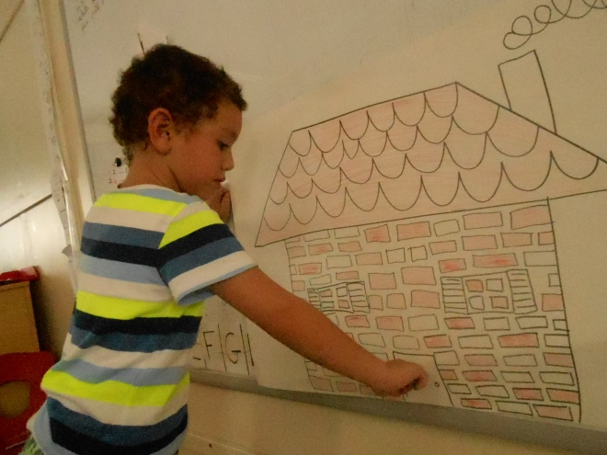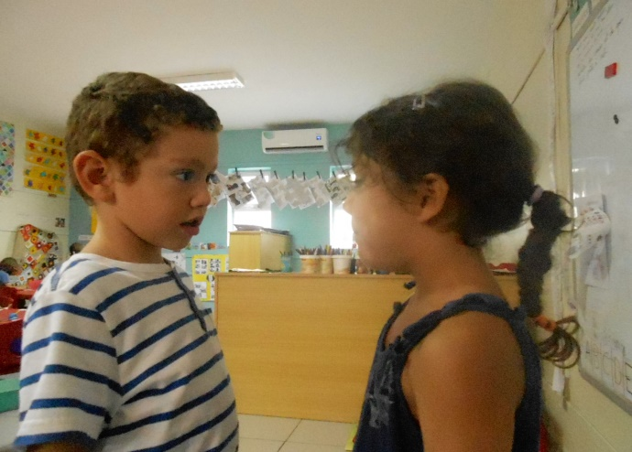
I am puffing and puffing and blowing your house down !

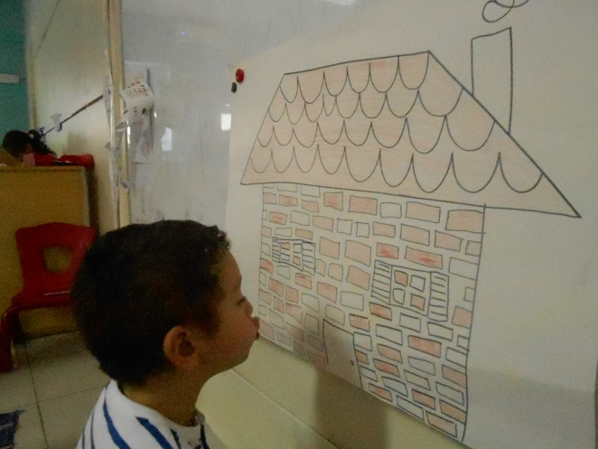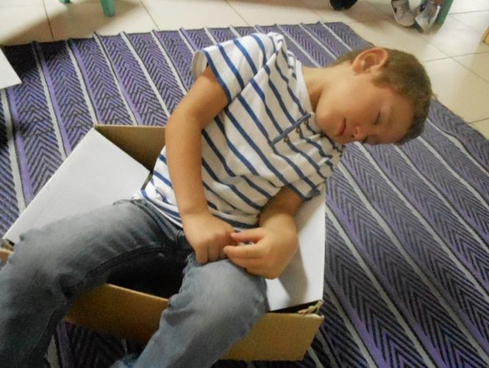
SPLASH !
The big bad wolf is falling down in the very hot soup !

AND THAT IS THE END !

