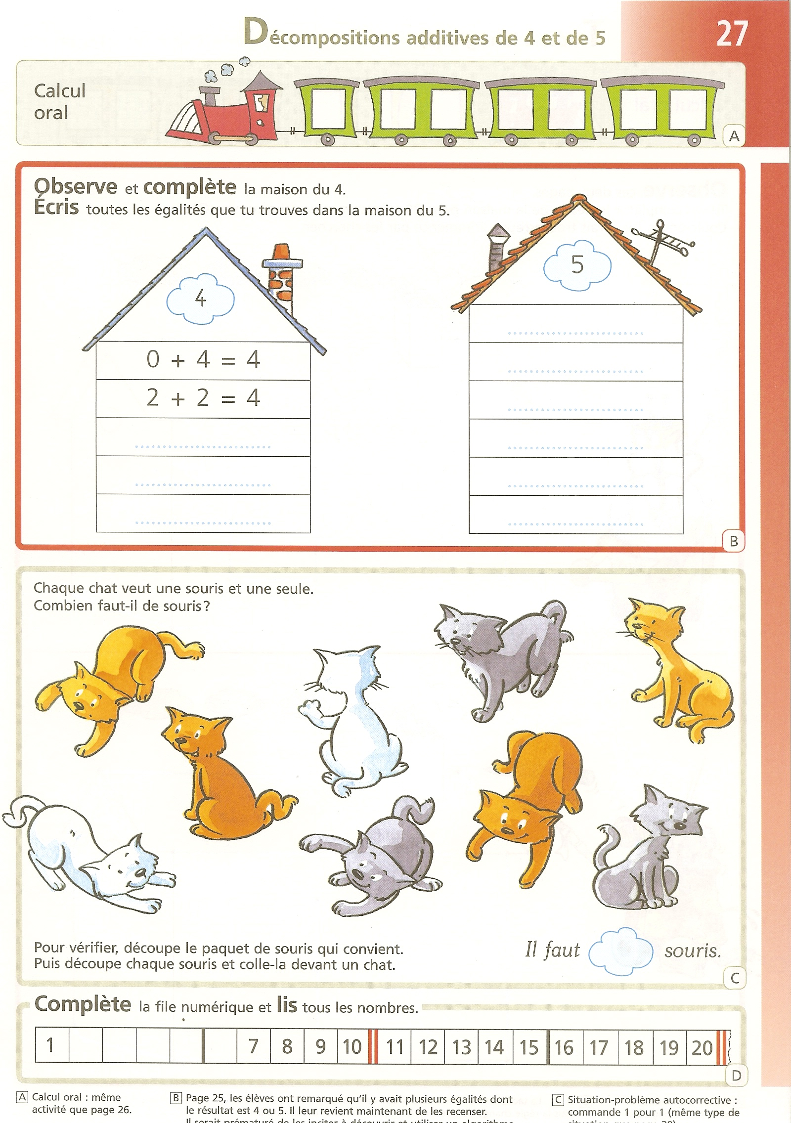
Sums corresponding to 4 and 5

Mental arithmetic

Observe and complete the house of 4.
Write down all the possible equations in the house of 5.

Each cat wants only one mouse. How many mice will it take?

To check, cut out the right set of mice at the end of this book. Then cut out each mouse and stick it in front of each cat.
It takes
mice.
Complete the number line and read all the numbers in it.

A. Mental arithmetic: same activity as on page 26 | B. On page 25, the learners have noticed that there are several sums having 4 or 5 as a result. Now, they must make an inventory of all those possible sums. At this stage, it would be too early to incite them to use an exhaustive algorithm such as 0 + n, 1 + n, 2 + n… | C. Problem situation: checking counting by one-to-one mapping (same situation as on page 20)

