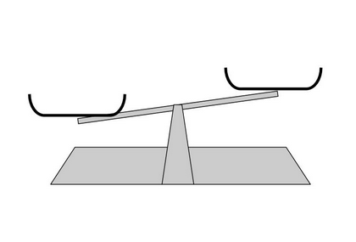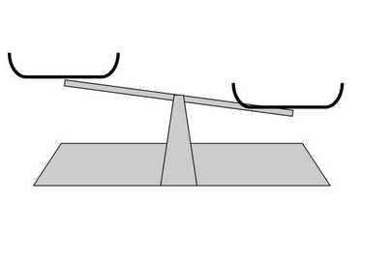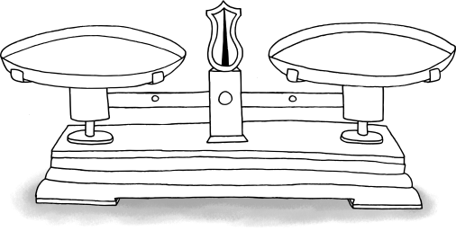

1 g

1 g

1 g

10 g

10 g

10 g



100 g

100 g

100 g

500 g

500 g

500 g



1 kg

1 kg

1 kg

1 tonne

1 tonne

1 tonne